**Veer Narmad South Gujarat University, Surat.**

**Department of Information and Communication Technology**

**M.Sc. (Information Technology) Programme**

# Project Report

**9th Semester**

**M.Sc. (Information Technology)**

**5 Year Integrated Course**

**Year 2023 – 2024**

## Pizza Delivery System

## (with Kafka and Rest)

|  |  |
| --- | --- |
| Guided By:  **Dr. Pushpal Desai**  **(Internal Guide)** | Submitted By:  **Morena Kiyan Rustom**  E19110018000610072  **Jadhav Kunal Ajay**  E19110018000610034  **Jariwala Bhavin Jasminkumar**  E19110018000610037  **Bhatt Jaiminkumar Urvishkumar**  E19110018000610009  **Patel Raj Rajnikant**  E19110018000610106 |

**Veer Narmad South Gujarat University, Surat.**

**Department of Information and Communication Technology**

**M.Sc. (Information Technology) Programme**

##### **Certificate**

This is to certify that Mr. **Morena Kiyan Rustom** with Exam Seat Number: **28** and PG Registration Number: **E19110018000610072** has worked on his/her part time project work entitled **Pizza Delivery System** as a partial fulfillment of the requirements for **9th** ***Semester - M.Sc. (Information Technology) [5 Year Integrated course]***, during the academic Year 2023-2024.

Date: 18/12/2023

Place: Dept. of ICT, VNSGU, Surat.

|  |  |
| --- | --- |
| **Internal Project Guide**  **M.Sc. (I.T.) 9th Semester**  **Department of I.C.T.**  **Veer Narmad** **South Gujarat University, Surat** | **Head of the Department**  **Department of I.C.T.**  **Veer Narmad** **South Gujarat University, Surat** |

**Veer Narmad South Gujarat University, Surat.**

**Department of Information and Communication Technology**

**M.Sc. (Information Technology) Programme**

##### **Certificate**

This is to certify that Mr. **Jariwala Bhavin Jasminkumar** with Exam Seat Number: **12** and PG Registration Number: **E19110018000610037** has worked on his/her part time project work entitled **Pizza Delivery System** as a partial fulfillment of the requirements for **9th** ***Semester - M.Sc. (Information Technology) [5 Year Integrated course]***, during the academic Year 2023-2024.

Date: 18/12/2023

Place: Dept. of ICT, VNSGU, Surat.

|  |  |
| --- | --- |
| **Internal Project Guide**  **M.Sc. (I.T.) 9th Semester**  **Department of I.C.T.**  **Veer Narmad** **South Gujarat University, Surat** | **Head of the Department**  **Department of I.C.T.**  **Veer Narmad** **South Gujarat University, Surat** |

**Veer Narmad South Gujarat University, Surat.**

**Department of Information and Communication Technology**

**M.Sc. (Information Technology) Programme**

##### **Certificate**

This is to certify that Mr. **Jadhav Kunal Ajay** with Exam Seat Number: **11** and PG Registration Number: **E19110018000610034** has worked on his/her part time project work entitled **Pizza Delivery System** as a partial fulfillment of the requirements for **9th** ***Semester - M.Sc. (Information Technology) [5 Year Integrated course]***, during the academic Year 2023-2024.

Date: 18/12/2023

Place: Dept. of ICT, VNSGU, Surat.

|  |  |
| --- | --- |
| **Internal Project Guide**  **M.Sc. (I.T.) 9th Semester**  **Department of I.C.T.**  **Veer Narmad** **South Gujarat University, Surat** | **Head of the Department**  **Department of I.C.T.**  **Veer Narmad** **South Gujarat University, Surat** |

**Veer Narmad South Gujarat University, Surat.**

**Department of Information and Communication Technology**

**M.Sc. (Information Technology) Programme**

##### **Certificate**

This is to certify that Mr. **Bhatt Jaiminkumar Urvishkumar** with Exam Seat Number: **4** and PG Registration Number: **E1911008000610009** has worked on his/her part time project work entitled **Pizza Delivery System** as a partial fulfillment of the requirements for **9th** ***Semester - M.Sc. (Information Technology) [5 Year Integrated course]***, during the academic Year 2023-2024.

Date: 18/12/2023

Place: Dept. of ICT, VNSGU, Surat.

|  |  |
| --- | --- |
| **Internal Project Guide**  **M.Sc. (I.T.) 9th Semester**  **Department of I.C.T.**  **Veer Narmad** **South Gujarat University, Surat** | **Head of the Department**  **Department of I.C.T.**  **Veer Narmad** **South Gujarat University, Surat** |

**Veer Narmad South Gujarat University, Surat.**

**Department of Information and Communication Technology**

**M.Sc. (Information Technology) Programme**

##### **Certificate**

This is to certify that Mr. **Patel Raj Rajnikant** with Exam Seat Number: **46** and PG Registration Number: **E1911008000610106** has worked on his/her part time project work entitled **Pizza Delivery System** as a partial fulfillment of the requirements for **9th** ***Semester - M.Sc. (Information Technology) [5 Year Integrated course]***, during the academic Year 2023-2024.

Date: 18/12/2023

Place: Dept. of ICT, VNSGU, Surat.

|  |  |
| --- | --- |
| **Internal Project Guide**  **M.Sc. (I.T.) 9th Semester**  **Department of I.C.T.**  **Veer Narmad** **South Gujarat University, Surat** | **Head of the Department**  **Department of I.C.T.**  **Veer Narmad** **South Gujarat University, Surat** |

**Index**

|  |  |  |
| --- | --- | --- |
| **Sr. No** | **Topics** | **Page no** |
| 1 | Introduction   * 1. Project Profile      1. Current System      2. Project Details | 8 |
| 2 | Proposed System  2.1 Scope  2.2 Objective  2.3 Advantages  2.4 Limitation | 10 |
| 3 | Environment Specification  3.1 Hardware Requirements  3.2 Software Requirements | 12 |
| 4 | System Planning  4.1 Feasibility Study  4.2 Software Engineering Model  4.3 Project Schedule | 13 |
| 5 | System Analysis  5.1 Detailed SRS  5.2 UML Diagram  5.2.1 Use Case Diagram  5.2.2 Activity Diagram  5.2.3 Sequence Diagram  5.2.4 Class Diagram  5.3 E-R Diagram | 15 |
| 6 | Software Design  6.1 Database Design  6.2 Interface Design | 33 |
| 7 | Testing | 51 |
| 8 | Future Enhancement | 52 |
| 9 | Reference | 53 |

1. **Introduction**

**1.1 Project profile**

|  |  |
| --- | --- |
| **Properties** | **Description** |
| Project Title | Pizza Delivery System ( with Kafka and Rest ) |
| Project  Definition | A Pizza Shop wants to accept order from a customer and supply them the Pizza order on satisfactory completion of payment. |
| Technology & Tools | Java 8, Java Micro-profile, NetBeans IDE 15, Visual Studio Code, Git, Kafka MQ. |
| Front End | React JavaScript Framework. |
| Back End | Java Enterprise Beans, MySQL, Jakarta EE Micro-profile/ Kafka Messaging Service, MP-JWT Authorization. |
| Internal Guide | Dr. Pushpal Desai. |
| Submitted To | J.P DAWER INSTITUTE OF INFORMATION SCIENCE AND TECHNOLOGY |

* + 1. **Current System**
* A Pizza Shop wants to accept order from a customer from a web interface and supply them the Pizza order on satisfactory completion of payment.
* Customer will place order and after payment the pizza will be delivered through deliver person.
* The whole system is based on Microservice Architecture, primarily built for testing and comparing the response time during the inter-service communications using Kafka and REST Services.
  + 1. **Project Details**
* There are four roles in this system: Admin, Customer, Delivery Person and Outlet.
* Admin will have rights to manage Items, Item category, Delivery persons and Outlets.
* Customer will Sign up/Login with 10000 Credits in his/her account. After logging in a list of available items will be displayed on the dashboard.
* Customer will have an option to add items to a cart. After adding items to the cart, customer will checkout for the order.
* Before placing the order, a payment prompt will open and customer will be given options to pay free with available credits or COD.
* After successful payment customer will see the order history.
* Outlet dashboard will have the list of Items that are ordered and are currently preparing.
* After the preparation of orders, the Outlet manager will checkout the order for delivery by allocating a random delivery person for delivery.
* As soon as the outlet manager allocates the delivery person. The delivery person will have a list of his pending deliveries.
* When the delivery person reaches to the delivery address, he/she will ask for the delivery code from the customer. After verifying the code the order status will be updated to delivered.

1. **Proposed System**
   1. **Scope**

* This system is designed to enhance the business by providing online food delivery.
* Scope Online Pizza Ordering System will be a web-based application. The application will be able to cater three roles namely - Admin, Outlet, Customer and Delivery person.
* Customer Characteristics
  + Registration
  + Login
  + Search and View Item Menu
  + Add item into the cart
  + Do Payment
  + Check Order Status
  + Check Order History
* Admin Characteristics
  + Login
  + Manage Food items
  + Manage Delivery Persons
  + Manage Item categories
  + Manage outlets
* Outlet Characteristics
  + Login
  + Accept orders and payments.
  + Checkout order for transit and assign delivery person.
* Delivery Person Characteristics
  + Login
  + List of orders to deliver
  + Verify the delivery code.
  1. **Objectives**
* The main objective of the pizza delivering system is to compare the response time of the pizza ordering, billing, customers and delivery status efficiently by using Kafka and REST APIs with inter-service communication in Microservices architecture. The main objective of using such an architecture is to optimize for scalability, CI/CD and ease of management.
* There should be easy on-boarding of new developers by ensuring the size of the codebase for each service is relatively small using MSA.
* Functionality to use multiple technology stacks to create a single application as the communication between the services through technology independent protocols like REST and Kafka MQ should be provided.
* The application should be scalable on the cloud with only required services being replicated.
* The developers should be able to perform CI/CD for different services.
* The application must be able to simplify and improve efficiency of the ordering process for both customer and outlet owner.
* The primary motive behind selecting the Microservice Architecture for the development of the said application is to provide better scalability, fault tolerance and support for DevOps.

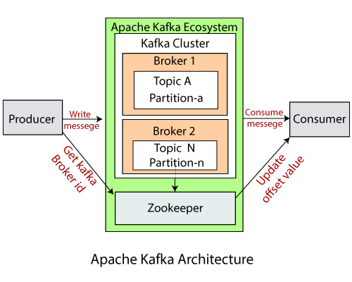

* 1. **Advantages**
* Kafka is an event driven streaming platform which publishes and subscribes and stores the messages makes the communication faster because everything will be asynchronous and will not be dependent on each other.
* Rest on the other hand uses the endpoints, JSON formats and client/server coupling and statelessness to make the communication easier. It will always provide you response in some format.
* By comparing the Kafka and Rest we conclude that Kafka is faster in interservice communication.
  1. **Disadvantages**
* Since purpose of project is to measure the performance of the system with both Kafka and rest Apis application is facing delays in case of getting response at end user.
* Rest implementations can be difficult because it is less secured and stateless but most of the applications are stateful.
* Interservice communication is difficult to implement in both Rest and Kafka

1. **Environment Specifications**

**3.1 Hardware Specifications**

|  |  |  |
| --- | --- | --- |
| **Hardware** | **Minimum** | **Recommended** |
| **Processor** | Intel 4th Generation processor (or equivalent) Intel i3/i5/i7/i9 | Intel 6th Generation Processor (or equivalent) Intel i3/i5/i7/i9 |
| **RAM** | 4 GB | 8 GB or better |
| **Display** | 1024 x 768, 24-bit color, or 1280 x 720, 24-bit color | 1920 x 1080, 32-bit color  (Or better) DirectX 9 or later |
| **Storage** | HDD Space 2Gb or more | SSD Space 2GB or more |

**3.2 Software Requirements**

|  |  |
| --- | --- |
| **Browser** | Google Chrome, Microsoft Edge, Safari, Firefox etc. |
| **Database** | MySQL |
| **Database Language** | SQL and JPQL |
| **Front End** | React JavaScript framework. |
| **Back End** | Java EE API. (EJB, JPA, REST), Kafka |
| **Operating System** | Windows, Linux, Mac OS |
| **Technology** | NetBeans IDE 13/15, Visual Studio Code |
| **Versioning Tool** | Git |

1. **System Planning**

**4.1 Feasibility Study**

Before the commencement of the development of this system, a proper feasibility study was conducted by the team. This included the aspects of schedule feasibility, technical feasibility and operational feasibility. The results of the study are as stated:

**Schedule Feasibility:**

* Various aspects were evaluated including the time required for training in new technologies and development of the project.
* As a result, a schedule of 7 weeks was established for the development of this project.

**Technical Feasibility:**

* In order for this system to be used, a user requires a computer or a mobile phone with a basic configuration along with a browser and a stable internet connection.
* The back-end database for this system is MySQL Server. This database was selected since using an SQL database was suitable for the system.
* An SQL Database was selected due to its capabilities of handling relationships among the data as well as availability. There are desirable qualities since the application would be used by multiple users simultaneously from various locations.
* The need for consistency is less as slightly less consistent data will not hamper the general usage of this system.
* For the front-end development, Java Server Faces along with the Prime Faces framework is selected as guided by our faculty.

**Operational Feasibility**

* This project is developed for the benefit of the Customers who tends to order online food with better experience.
* In the modern era, technologies have penetrated into our lives deeply. As a result, a majority of people are equipped with smart phones and internet connection.
* For a user to use this system, they must have a basic computer of any kind, browser installed and a stable internet connection.

**4.2 Software Engineering Model**

* For the development of Pizza Delivery System, the Rapid Application Development (RAD) Model was used. RAD approached to software development put less emphasis on planning and more emphasis on an adaptive process.
* Prototypes are often used in addition to or sometimes even instead of design specifications.

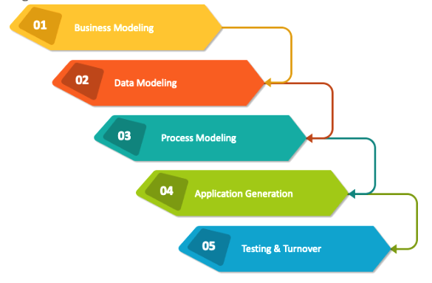

**4.3 Project Schedule**

|  |  |  |  |
| --- | --- | --- | --- |
| Tasks | Start Date | Duration (Days) | End Date |
| Requirement Gathering | 20/10/2023 | 2 | 22/10/2023 |
| Design | 27/10/2023 | 3 | 30/10/2023 |
| Learning + Coding | 15/11/2023 | 33 | 18/12/2023 |
| Testing | 18/12/2023 | 1 | 19/12/2023 |
| Rework and Documentation | 17/12/2023 | 1 | 18/06/2023 |

**5. System Analysis**

**5.1 Detailed SRS**

**Common Module(s)**

|  |  |
| --- | --- |
| Module | Login |
| Description | Login to the system by providing credentials and get redirected to respective home page |
| Input | Login credentials |
| Output | Redirection to home page |

**Customer User**

|  |  |
| --- | --- |
| Module | Register |
| Description | The customers can register themselves by providing name, username, password and phone no. |
| Input | Registration details |
| Output | Response message |

|  |  |
| --- | --- |
| Module | Search and view Item Menu |
| Description | The customer is able to browse the available items to place an order. |
| Input | none |
| Output | Menu items |

|  |  |
| --- | --- |
| Module | Add item to cart/ view cart |
| Description | The customer is able to add items to a cart to go further with payment |
| Input | Menu Items |
| Output | Cart details |

|  |  |
| --- | --- |
| Module | Do payment |
| Description | The customer is able to pay for the order either by cash or store credit. |
| Input | Payment details |
| Output | Order summary |

|  |  |
| --- | --- |
| Module | Check order status |
| Description | Customers are able to check the status of their order. |
| Input | Order details |
| Output | Order status |

|  |  |
| --- | --- |
| Module | Check order history |
| Description | Customers are able to check the order history |
| Input | Customer details |
| Output | Order history details |

**Admin User**

|  |  |
| --- | --- |
| Module | Manage food items |
| Description | Add or delete food items in the restaurant menu |
| Input | Item details |
| Output | Response message |

|  |  |
| --- | --- |
| Module | Manage delivery person |
| Description | Approve new delivery person and add them or remove a delivery person |
| Input | delivery person details |
| Output | Response message |

|  |  |
| --- | --- |
| Module | Manage outlet |
| Description | Add or remove restaurant outlets |
| Input | Restaurant details |
| Output | Response message |

|  |  |
| --- | --- |
| Module | Manage item categories |
| Description | Add or remove item categories in restaurant menu |
| Input | Item category details |
| Output | Response message |

**Outlet user**

|  |  |
| --- | --- |
| Module | Accept orders |
| Description | Accept orders from users and start order preparation accordingly |
| Input | Order details (from user) |
| Output | Order details (on outlet dashboard) |

|  |  |
| --- | --- |
| Module | Checkout order for transit |
| Description | Change order status to in-transit once preparation is complete and delivery person is assigned |
| Input | Order details |
| Output | Response message |

**Delivery person user**

|  |  |
| --- | --- |
| Module | View orders to be delivered |
| Description | Details of order to be delivered are shown to the delivery person |
| Input | Delivery person details |
| Output | Order details |

|  |  |
| --- | --- |
| Module | Verify OTP |
| Description | The delivery person is able to verify the OTP given by the customer before handing them the order |
| Input | One Time Password |
| Output | Response message |

**5.2 UML Diagrams**

**5.2.1 Use Case Diagrams**

* **Admin Use Case**

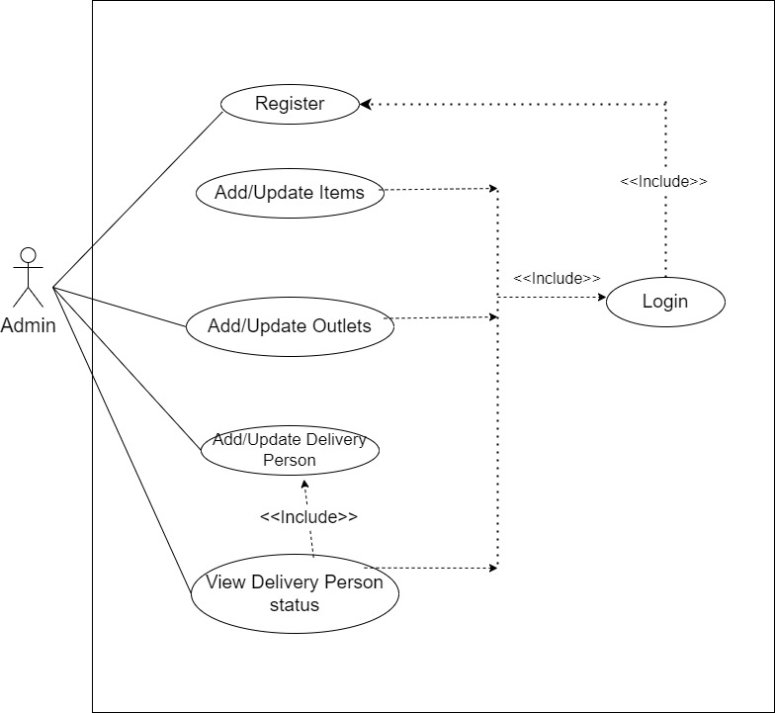

* **Customer Use Case**

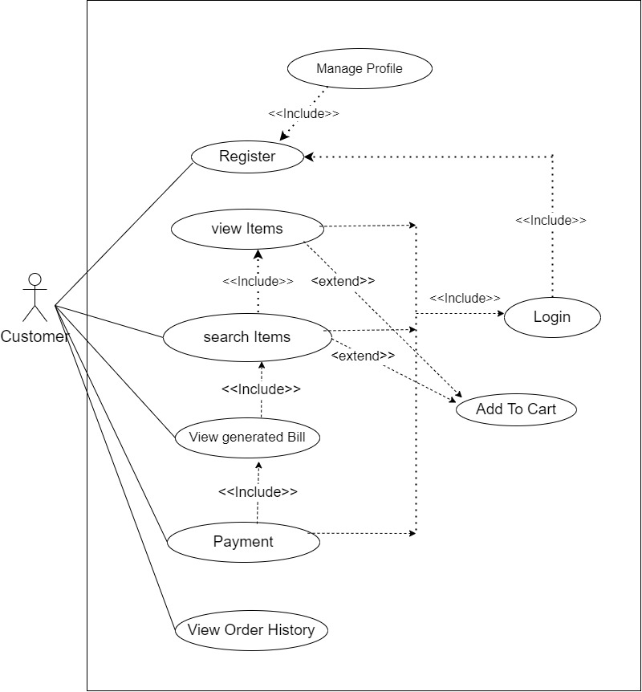

* **Delivery Person Use Case**

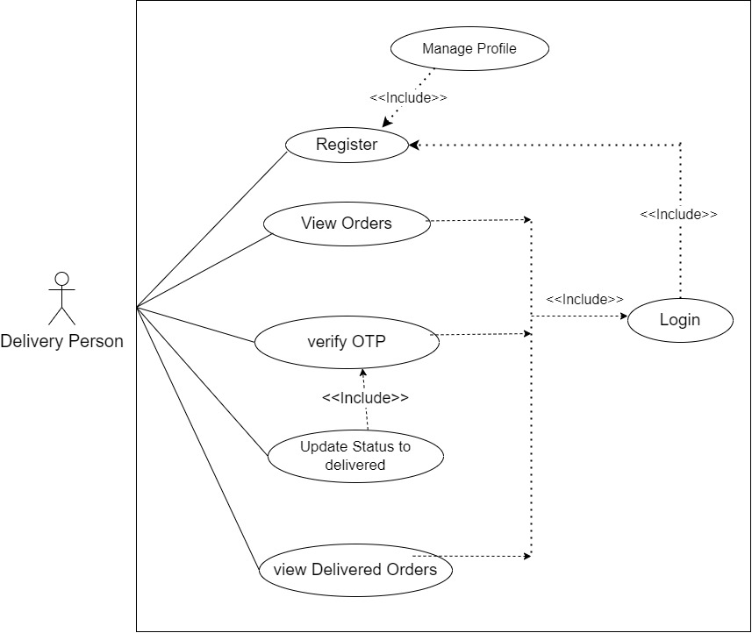

* **Outlet Use Case**

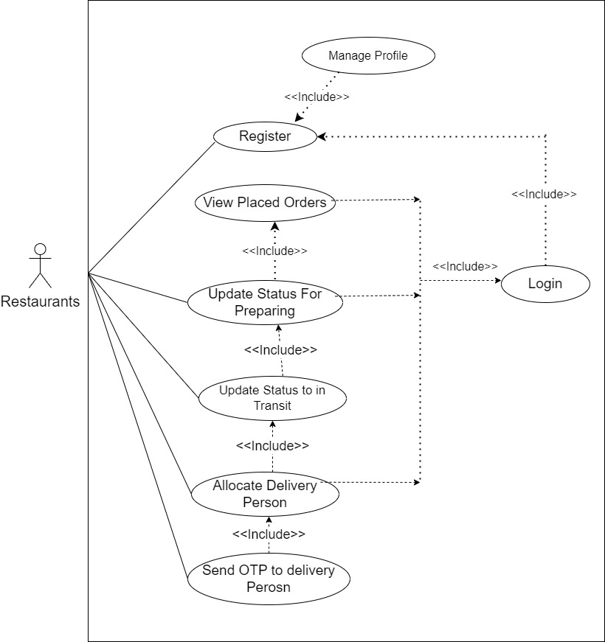

**5.2.2 Activity Diagrams**

* **Admin**

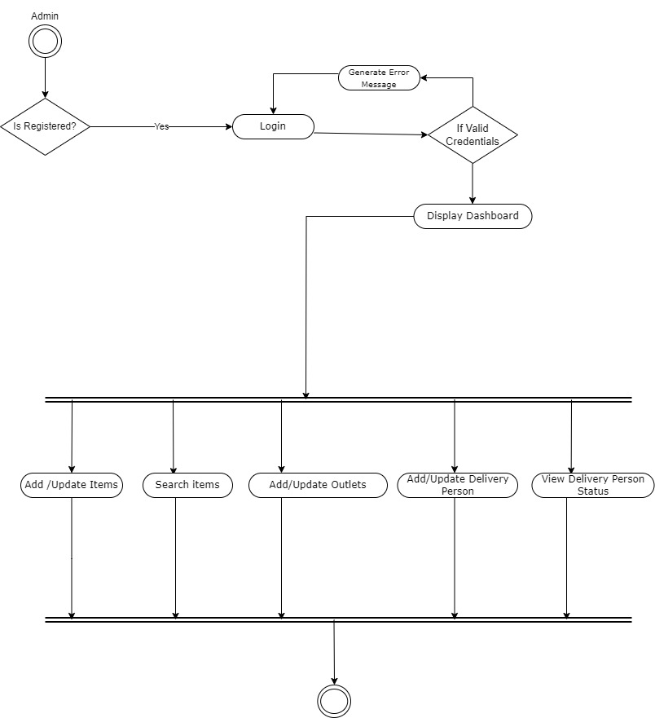

* **Customer**

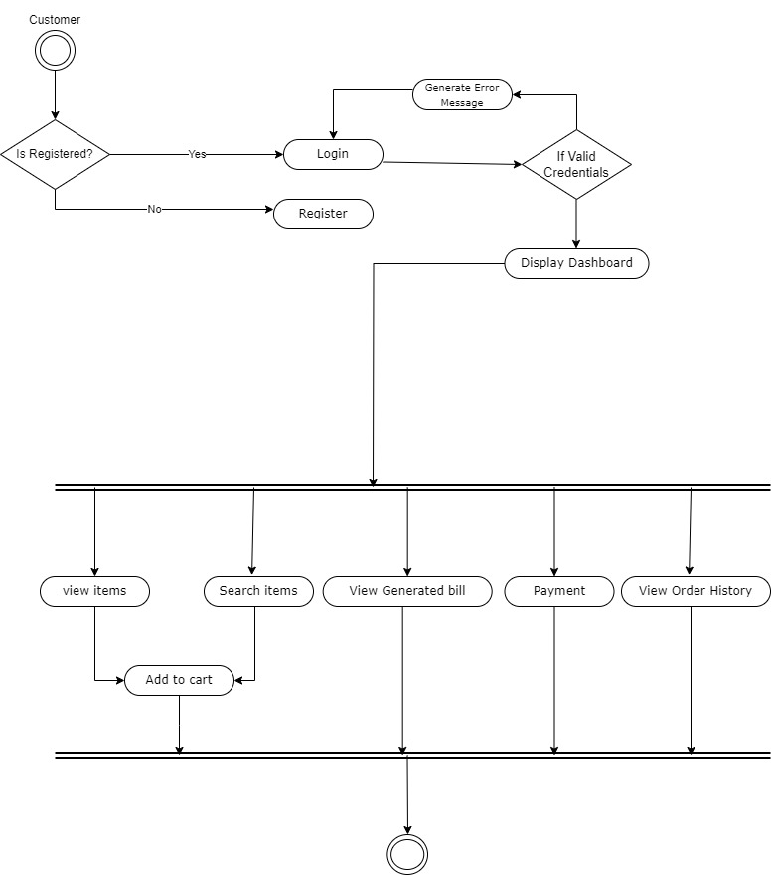

* **Delivery Person**

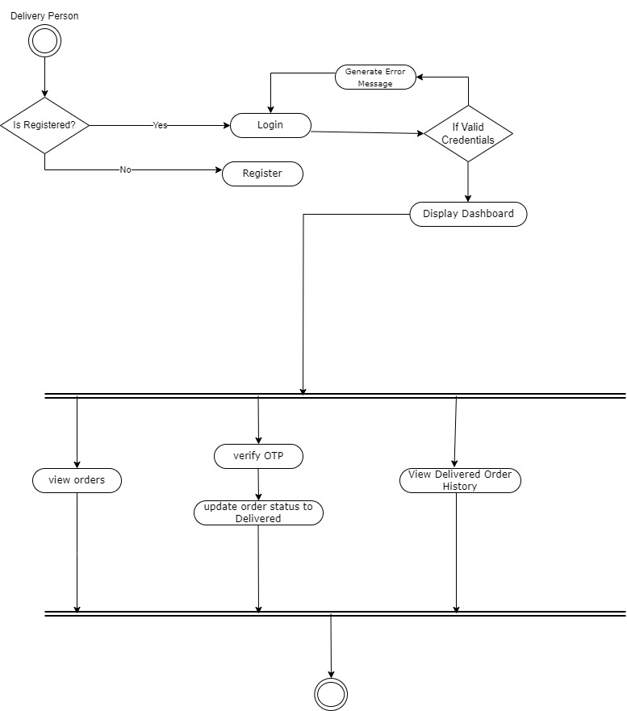

* **Outlets**

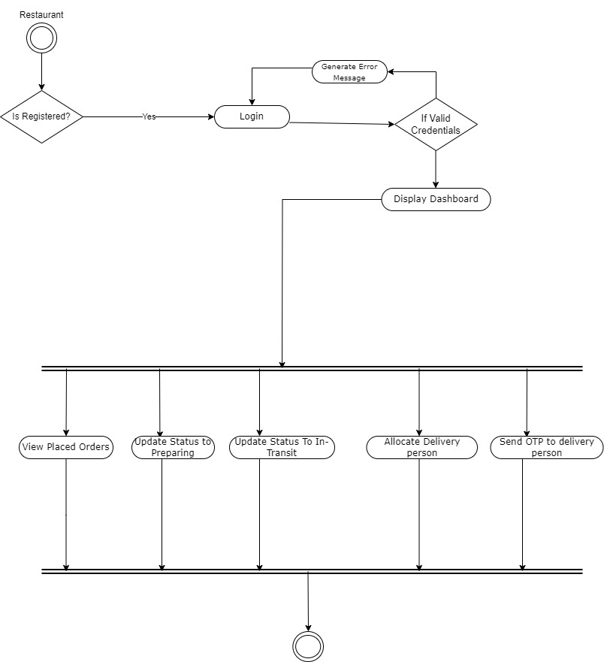

**5.2.3 Sequence Diagrams**

* **Admin**

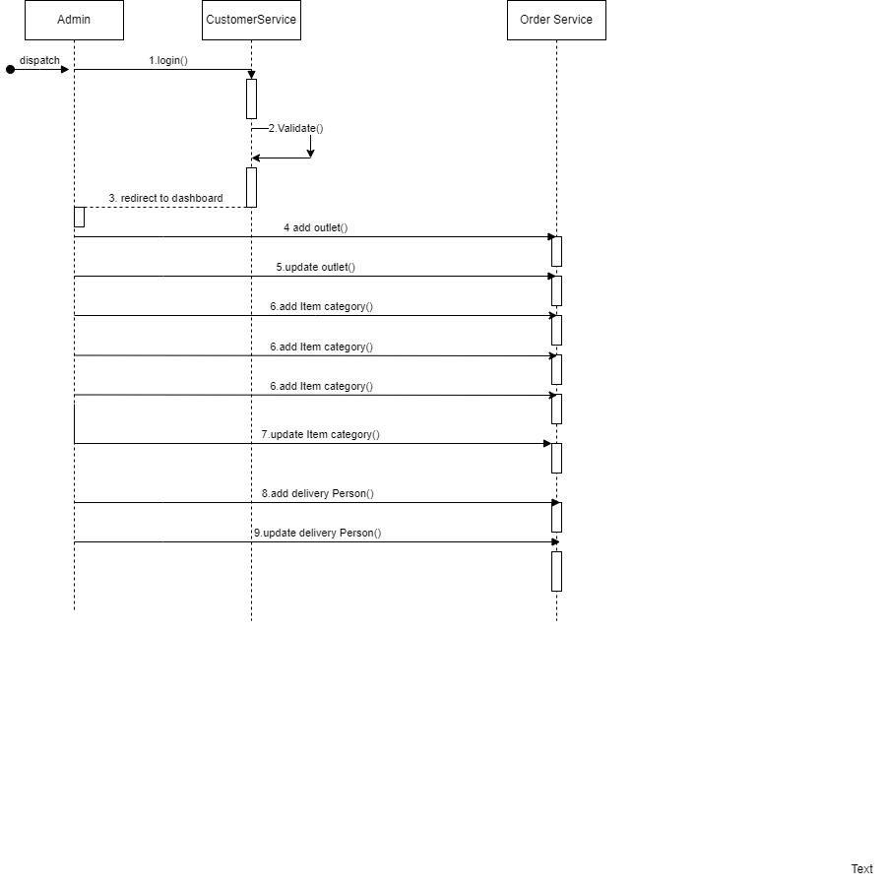

* **Customer**

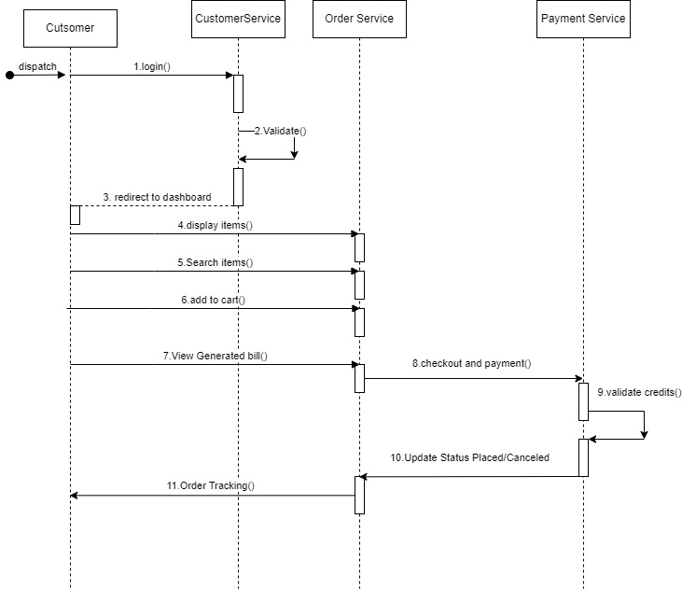

* **Delivery Person**

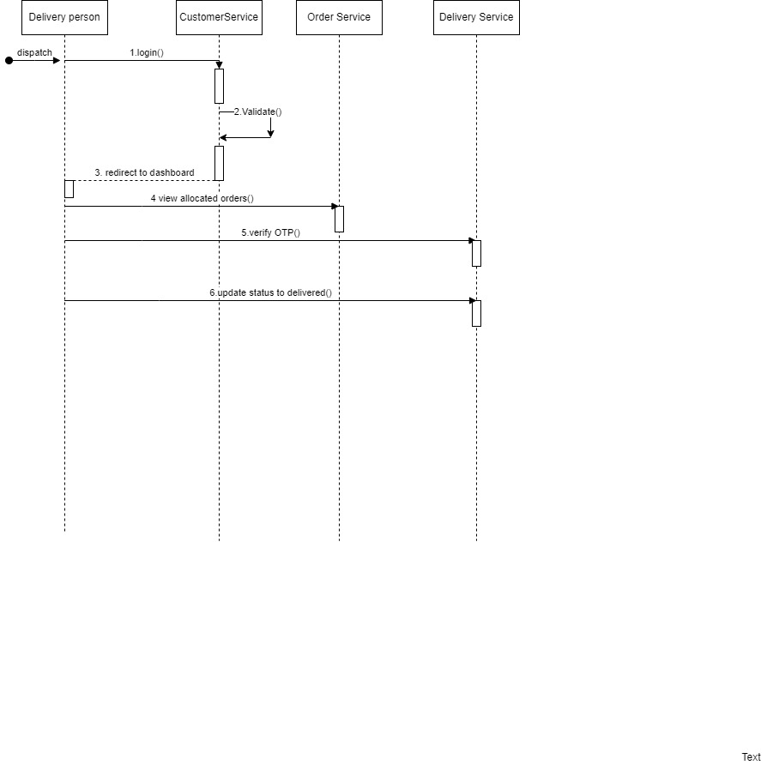

* **Outlet**

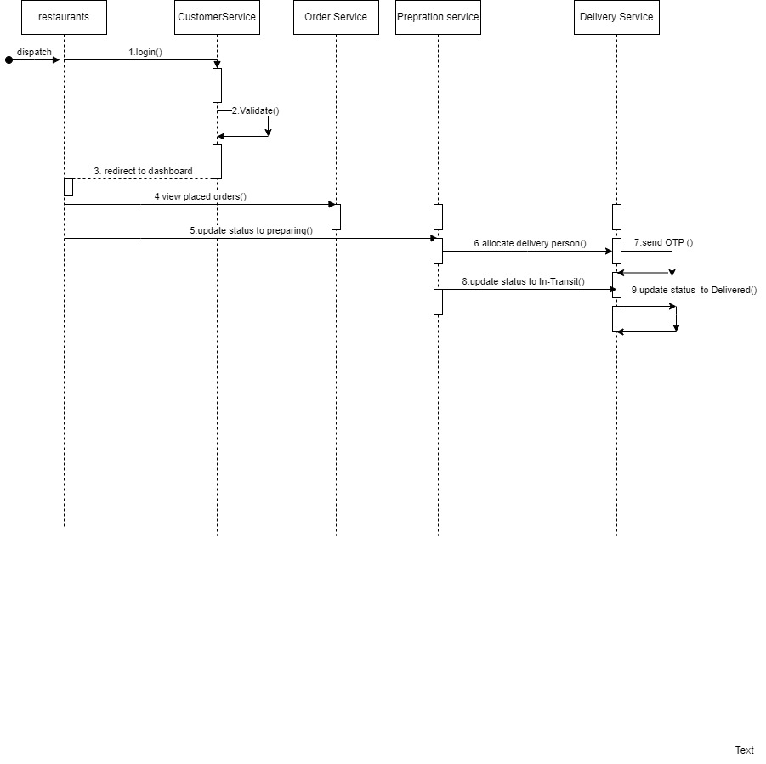

**5.2.4 Class Diagram**

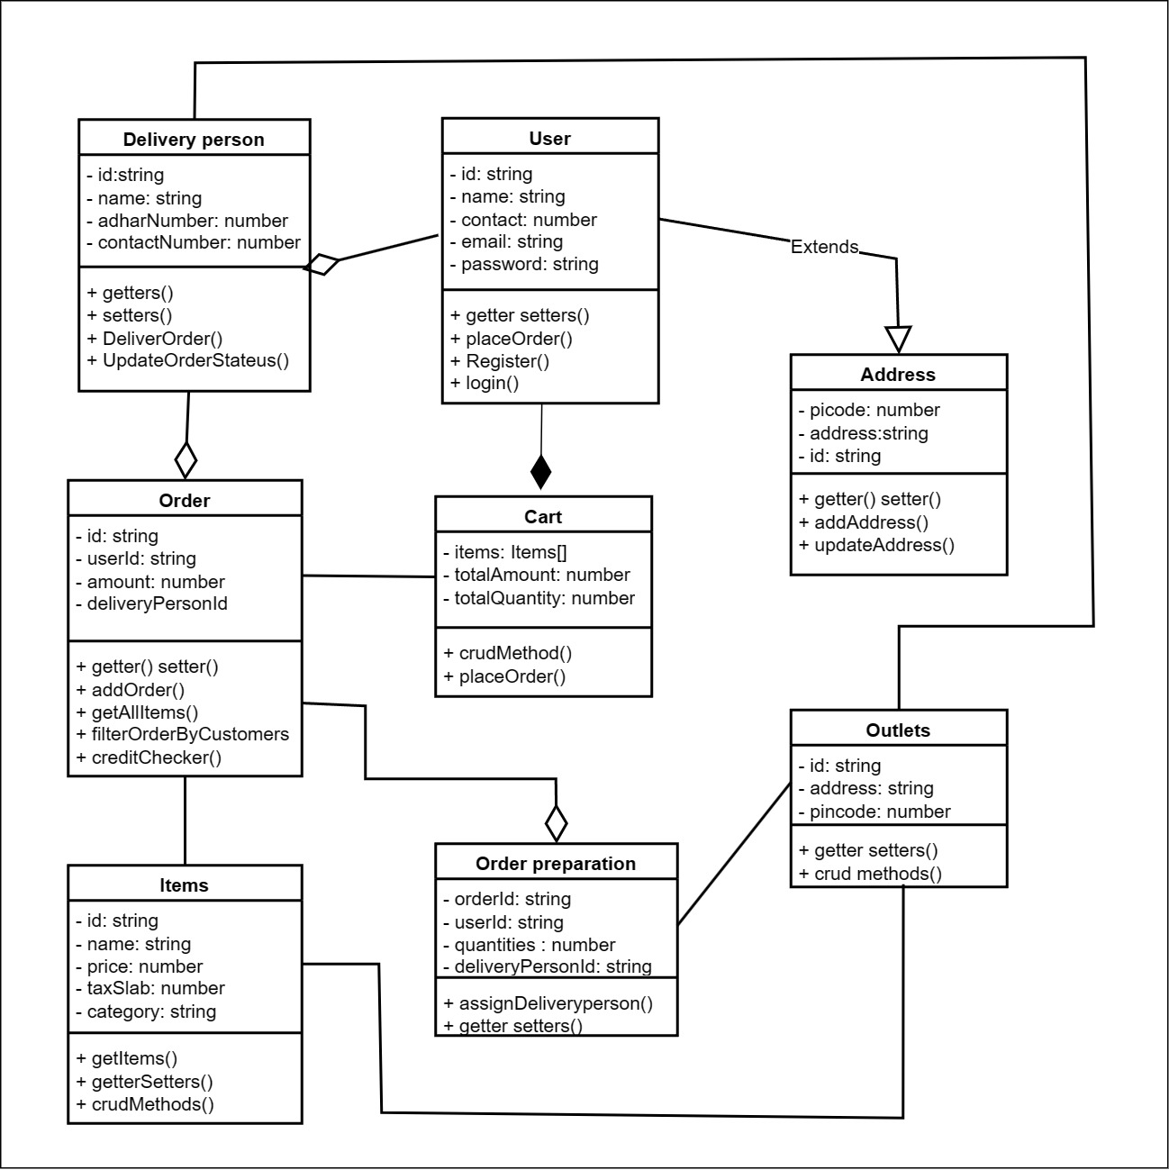

**5.3 ER Diagram**

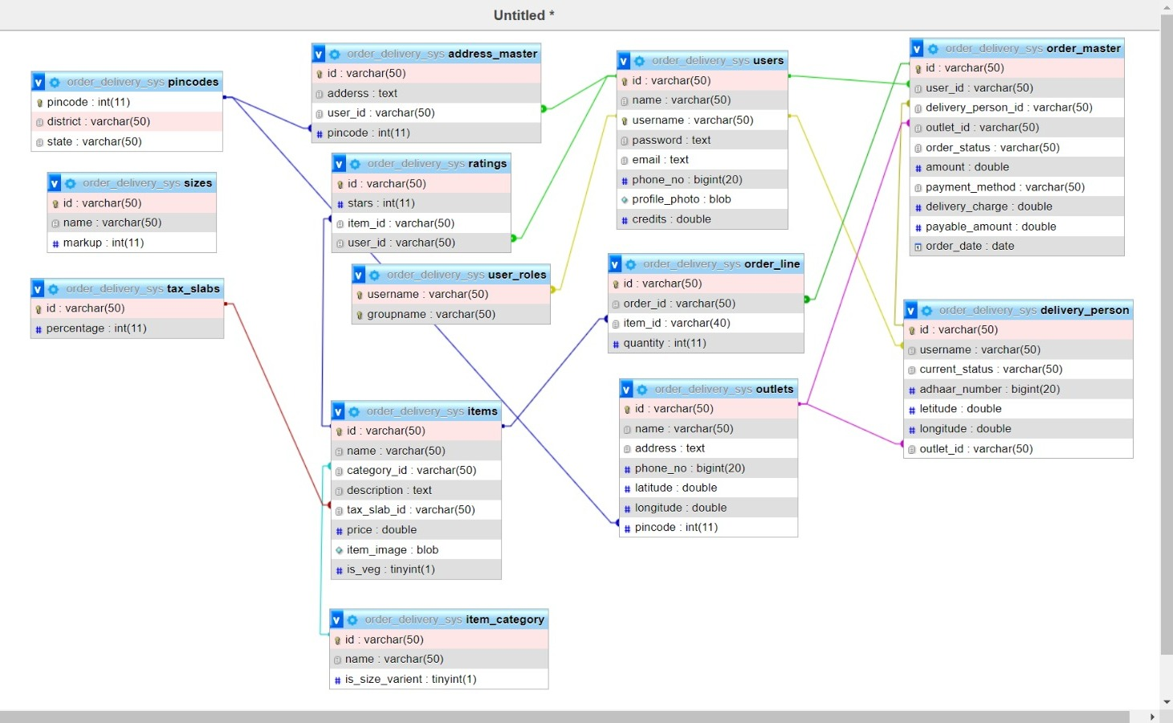

**6. Software Design**

**6.1 Database Design**

**Address Master**

|  |  |  |
| --- | --- | --- |
| **Field Name** | **Data Type** | **Constraints** |
| Id | Varchar (50) | Primary Key |
| address | text | Null |
| user_id | Nvarchar(100) | Foreign Key |
| pincode | Int(11) | Foreign Key |

**Delivery Person**

|  |  |  |
| --- | --- | --- |
| **Field Name** | **Data Type** | **Constraints** |
| id | Varchar(50) | Primary Key |
| username | Varchar(50) | Foreign key |
| current_status | Varchar(50) | Null |
| aadhaar_number | BigInt(20) | Null |
| letitude | double | Null |
| longitude | Double | Null |
| Outlet_id | Varchar(50) | Null |

**Items**

|  |  |  |
| --- | --- | --- |
| **Field Name** | **Data Type** | **Constraints** |
| id | Varchar(50) | Primary Key |
| name | Varchar(50) | Null |
| Category_id | Varchar(50) | Foreign key |
| description | text | Null |
| Tax_slab_id | Varchar(50) | Foreign key |
| price | Double | Null |
| Item_photo | Blob | Null |
| Is_veg | Tinyint(1) | Null |

**Item_category**

|  |  |  |
| --- | --- | --- |
| **Field Name** | **Data Type** | **Constraints** |
| id | Varchar(50) | Primary Key |
| name | Varchar(50) | Null |
| is_size_varient | Tinyint(1) | Null |

**Order_line**

|  |  |  |
| --- | --- | --- |
| **Field Name** | **Data Type** | **Constraints** |
| id | Varchar(50) | Primary Key |
| Order_id | Varchar(50) | Foreign key |
| Item_id | Varchar(50) | Foreign key |
| quantity | Int(11) | Null |

**orderMaster**

|  |  |  |
| --- | --- | --- |
| **Field Name** | **Data Type** | **Constraints** |
| Id | Varchar(50) | Primary key |
| User_id | Varchar(50) | Foreign key |
| delivery_person_id | Varchar(50) | Foreign key |
| outlet_id | Varchar(50) | Foreign key |
| order_status | Varchar(50) | Null |
| amount | double | Null |
| payment_method | Varchar(50) | Null |
| delivery_charge | double | Null |
| payable_amount | double | Null |
| order_date | date | Null |

**Outlets**

|  |  |  |
| --- | --- | --- |
| **Field Name** | **Data Type** | **Constraints** |
| Id | Varchar(50) | Primary key |
| Name | Varchar(50) | Null |
| Address | text | Null |
| Phone_no | BigInt(20) | Null |
| latitude | double | Null |
| logitude | double | Null |
| pincode | Int(11) | Foreign key |

**pincodes**

|  |  |  |
| --- | --- | --- |
| **Field Name** | **Data Type** | **Constraints** |
| pincode | Int(11) | Primary key |
| district | Varchar(50) | Null |
| state | Varchar(50) | Null |

**Ratings**

|  |  |  |
| --- | --- | --- |
| **Field Name** | **Data Type** | **Constraints** |
| Id | Varchar(50) | Primary key |
| stars | Int(11) | Null |
| item_id | Varchar(50) | Foreign key |
| user_id | Varchar(50) | Foreign key |

**Sizes**

|  |  |  |
| --- | --- | --- |
| **Field Name** | **Data Type** | **Constraints** |
| Id | Varchar(50) | Primary key |
| Name | Varchar(50) | Null |
| markup | Int(11) | Null |

**tax_slabs**

|  |  |  |
| --- | --- | --- |
| **Field Name** | **Data Type** | **Constraints** |
| Id | Varchar(50) | Primary key |
| percentage | Int(11) | Null |

**Users**

|  |  |  |
| --- | --- | --- |
| **Field Name** | **Data Type** | **Constraints** |
| Id | Varchar(50) | Primary key |
| name | Varchar(50) | Null |
| username | Varchar(50) | Foreign key |
| password | text | Null |
| email | text | Unique key |
| Phone_no | BigInt(20) | Null |
| Profile_photo | blob | Null |
| credits | double | Null |

**User Roles**

|  |  |  |
| --- | --- | --- |
| **Field Name** | **Data Type** | **Constraints** |
| username | Varchar(50) | Composite key |
| groupname | Varchar(50) | Composite key |

**6.2 Interface Design**

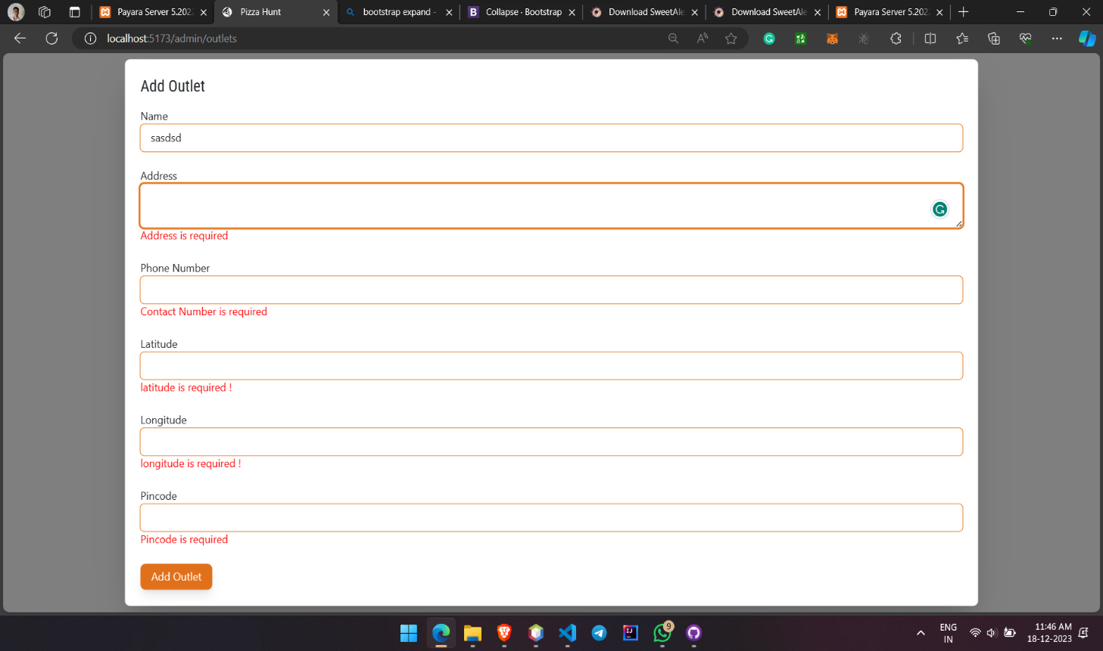

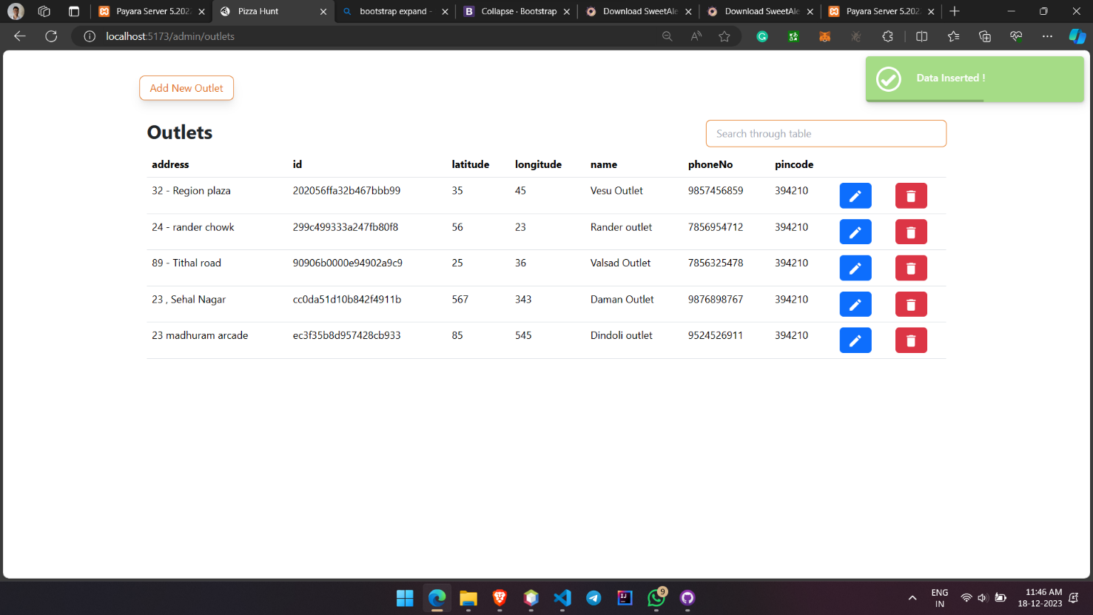

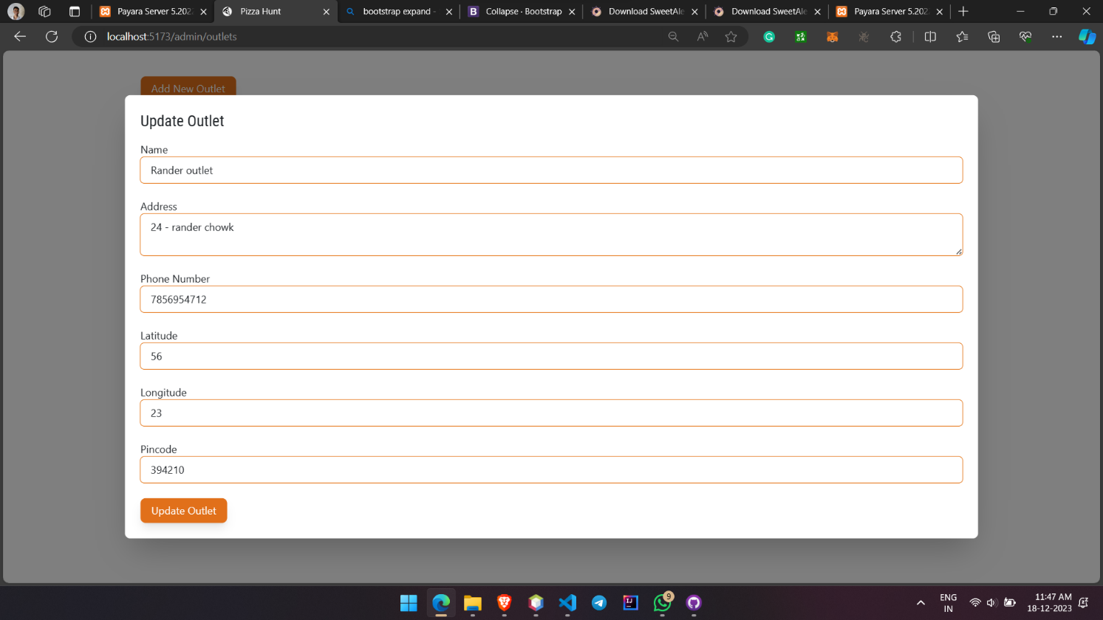

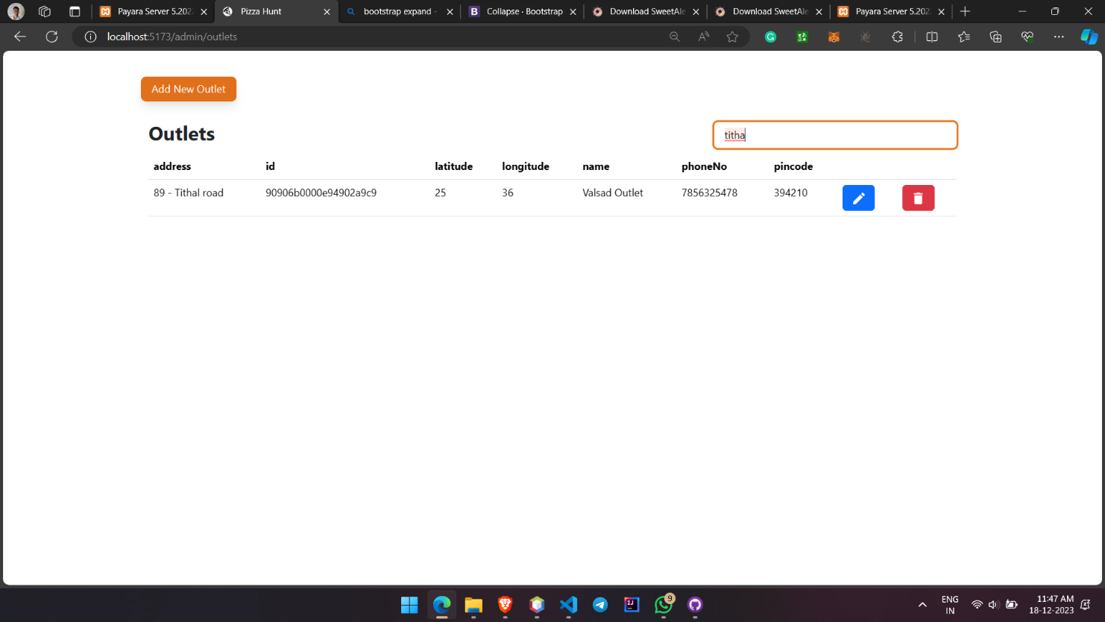

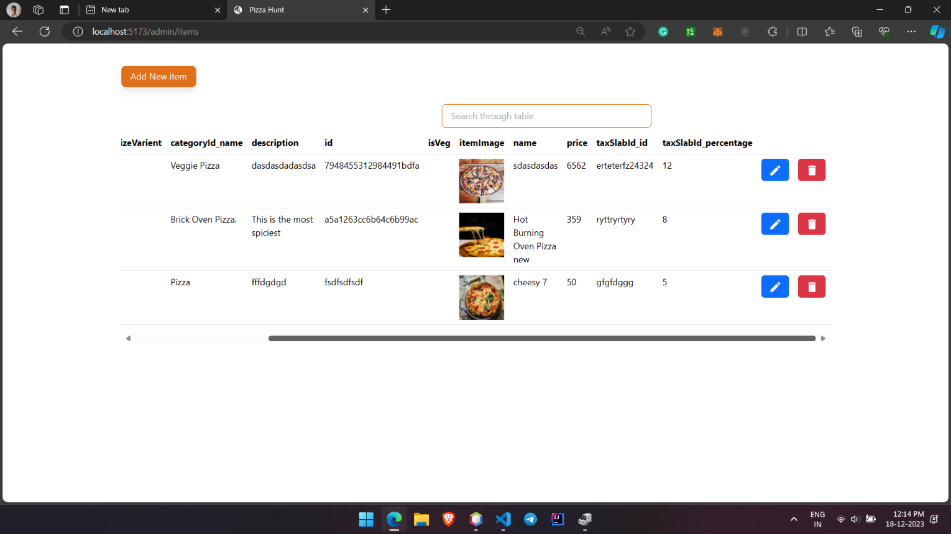

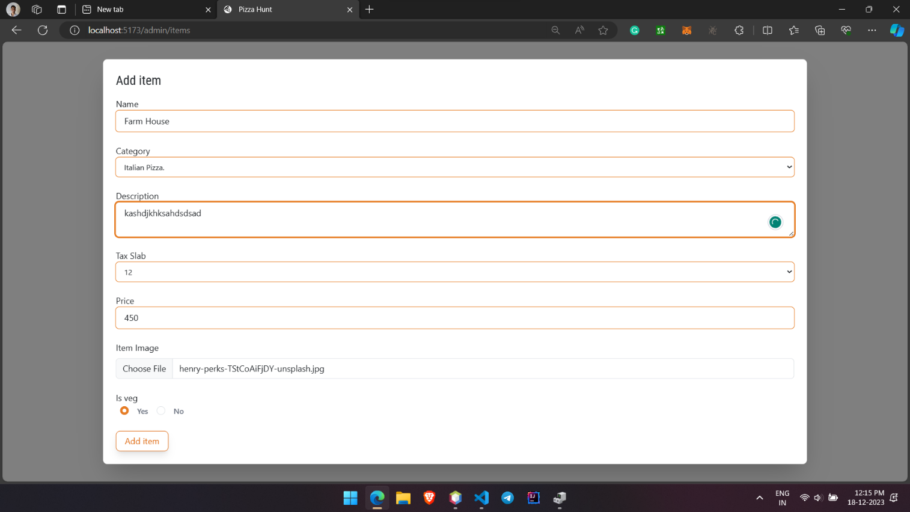

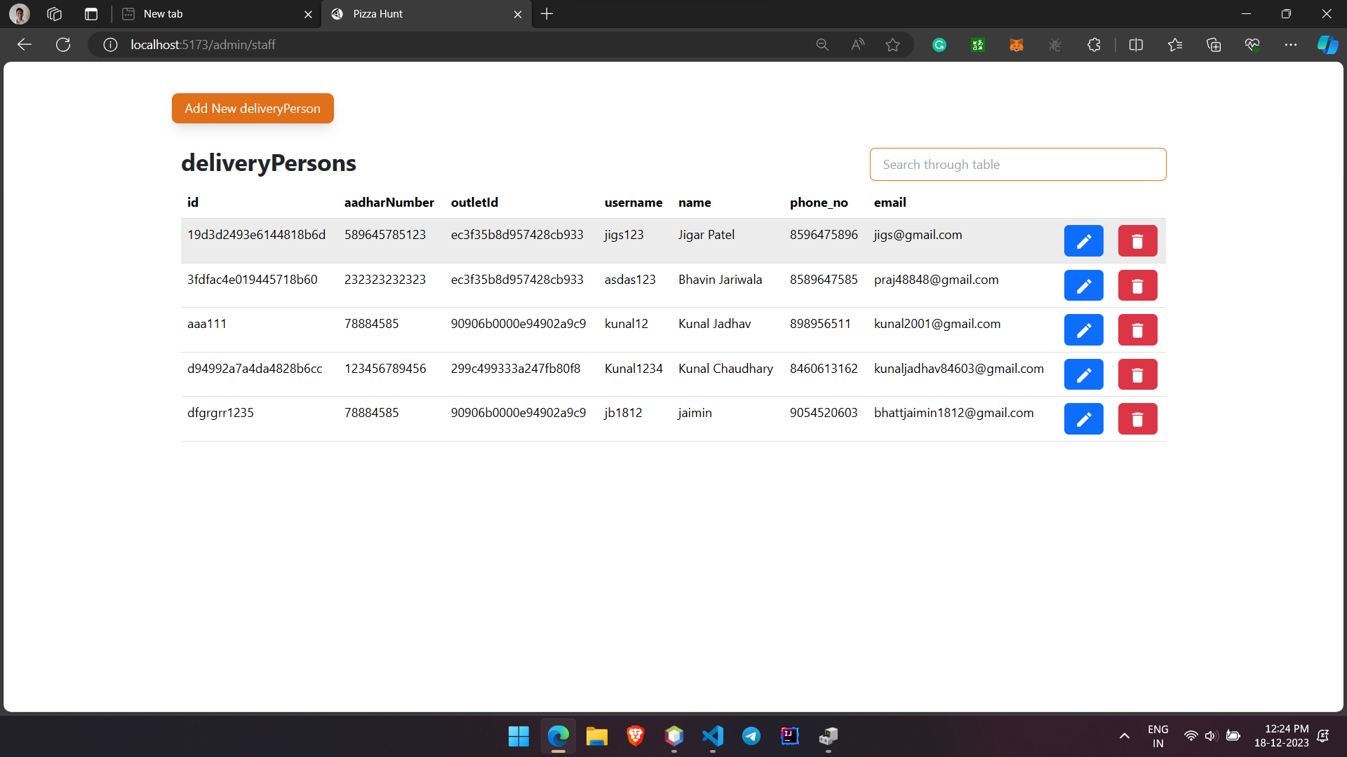

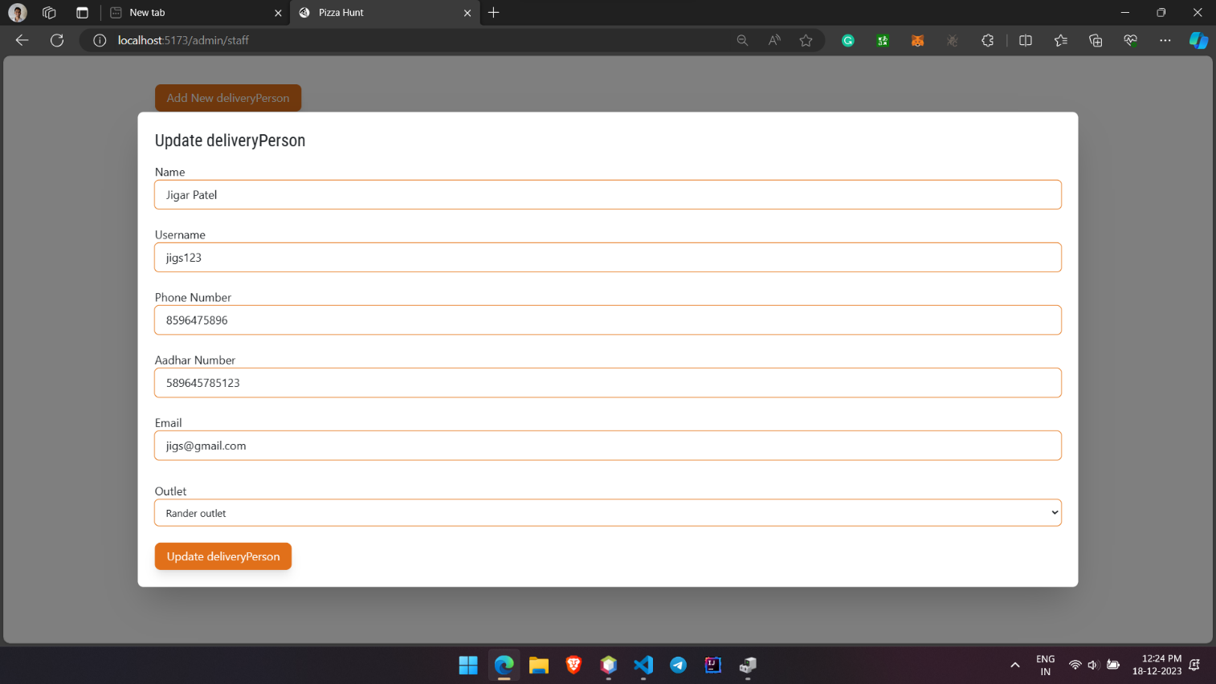

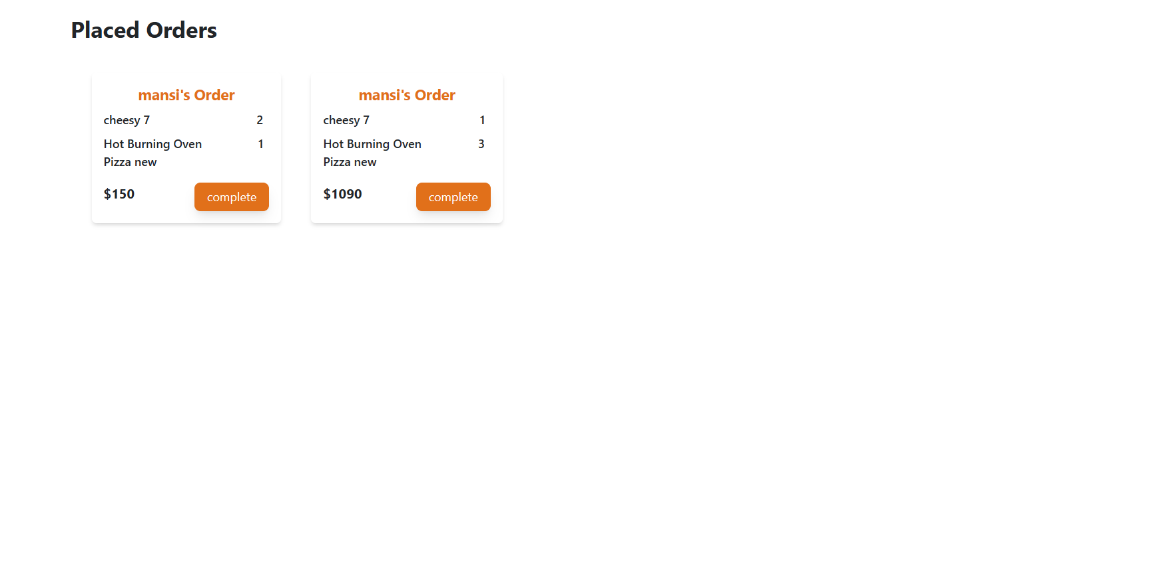

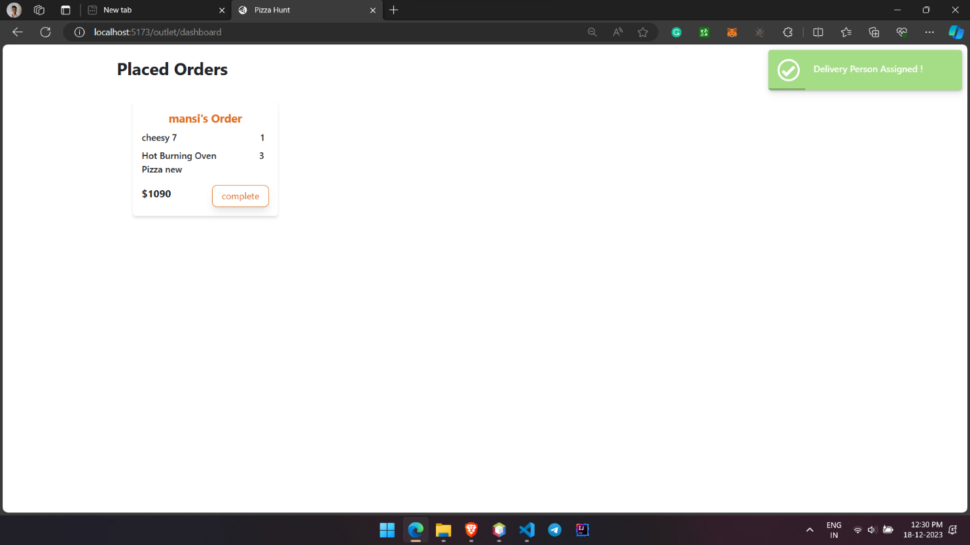

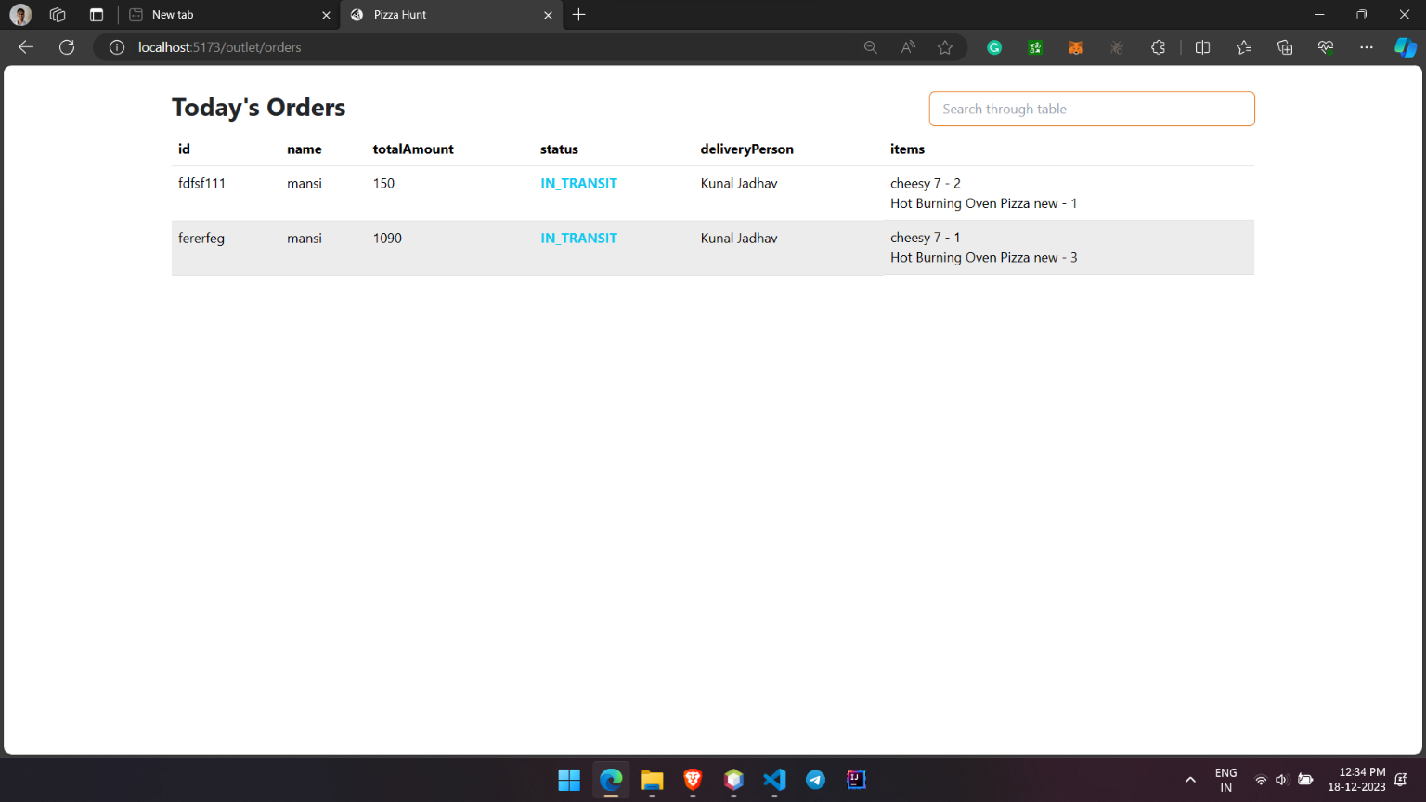

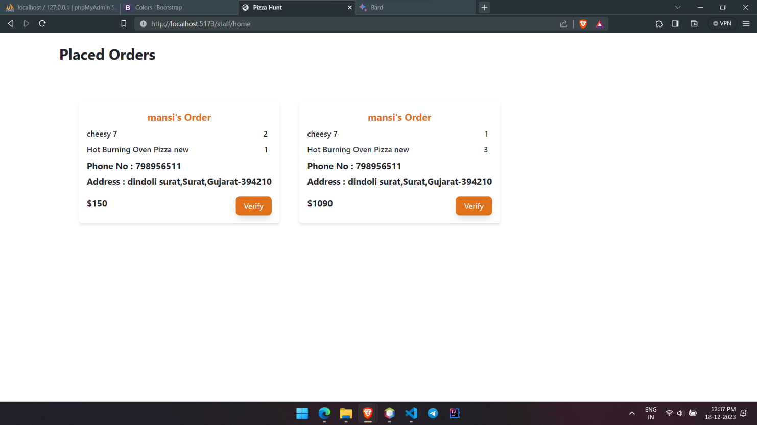

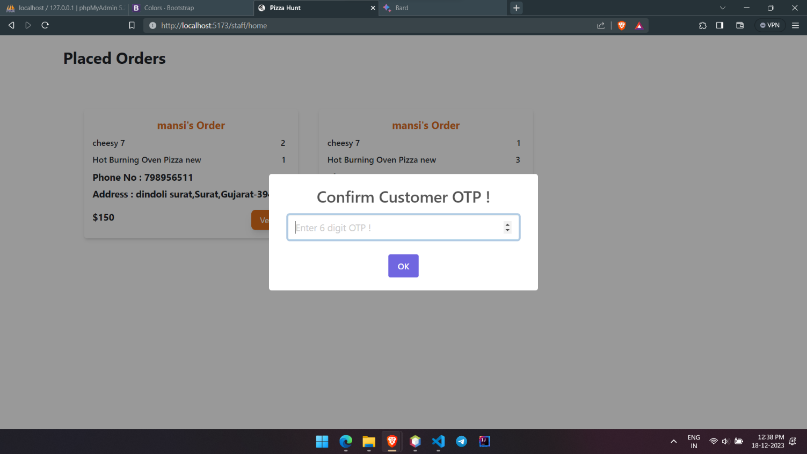

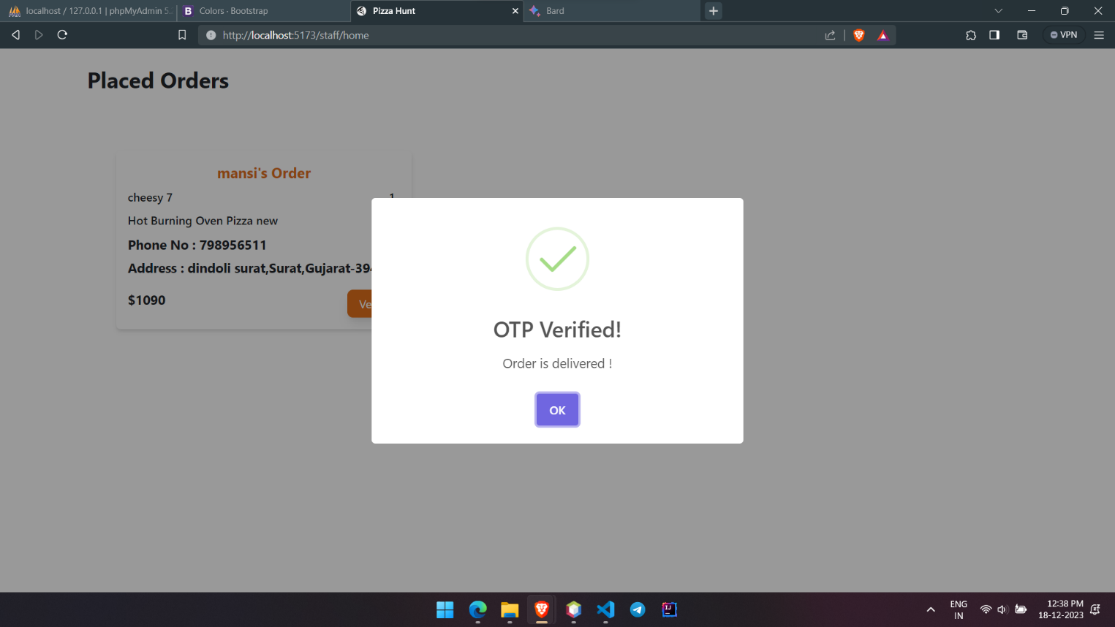

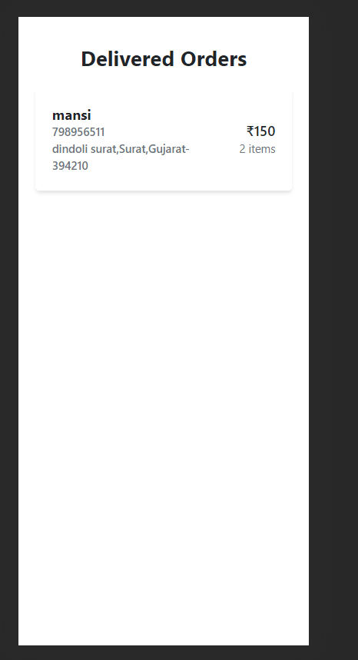

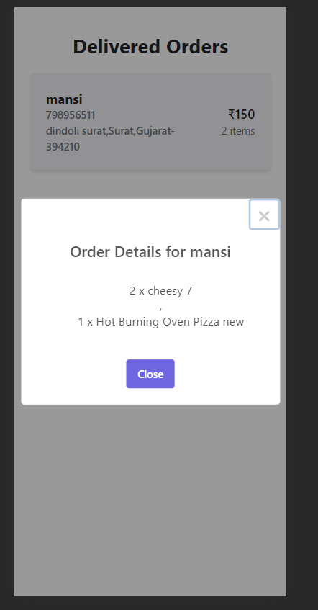

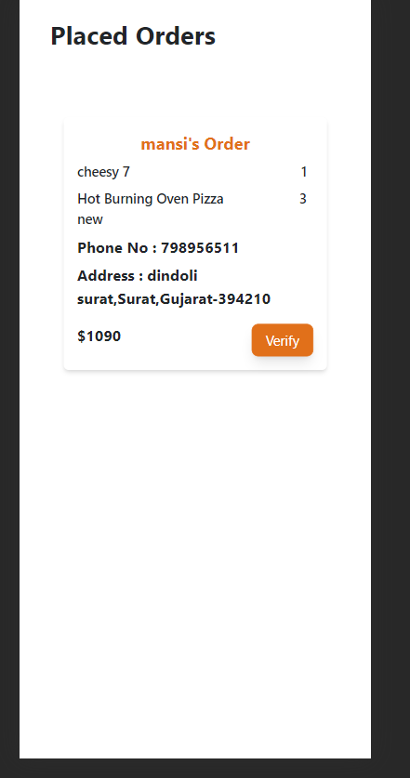

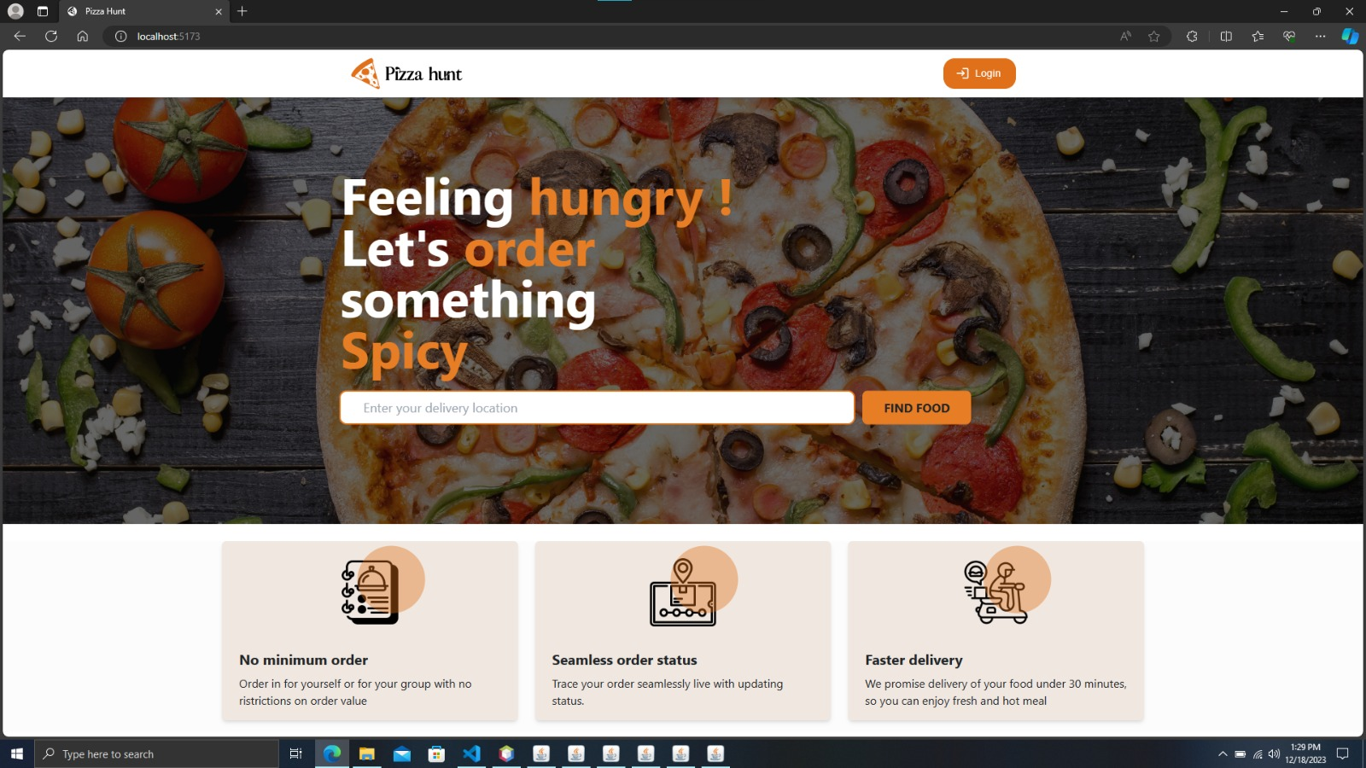

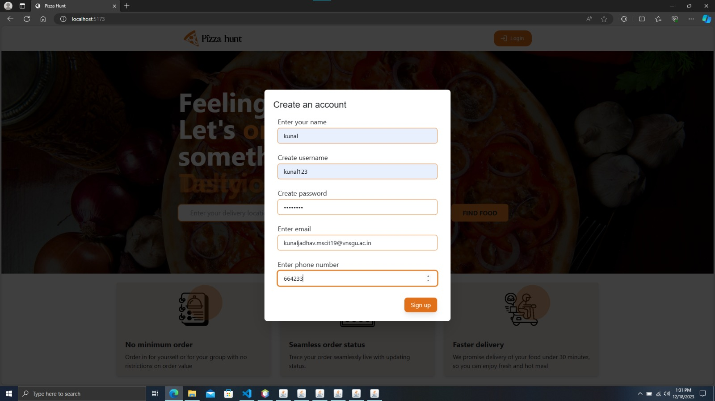

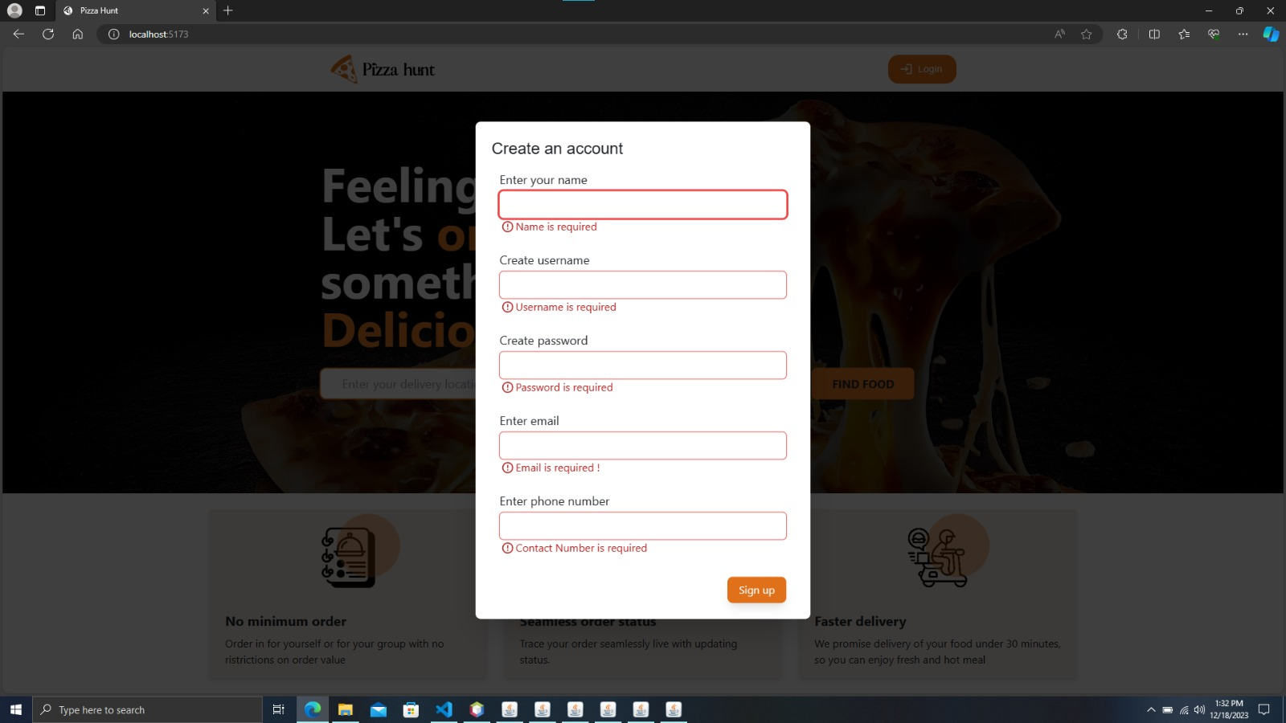

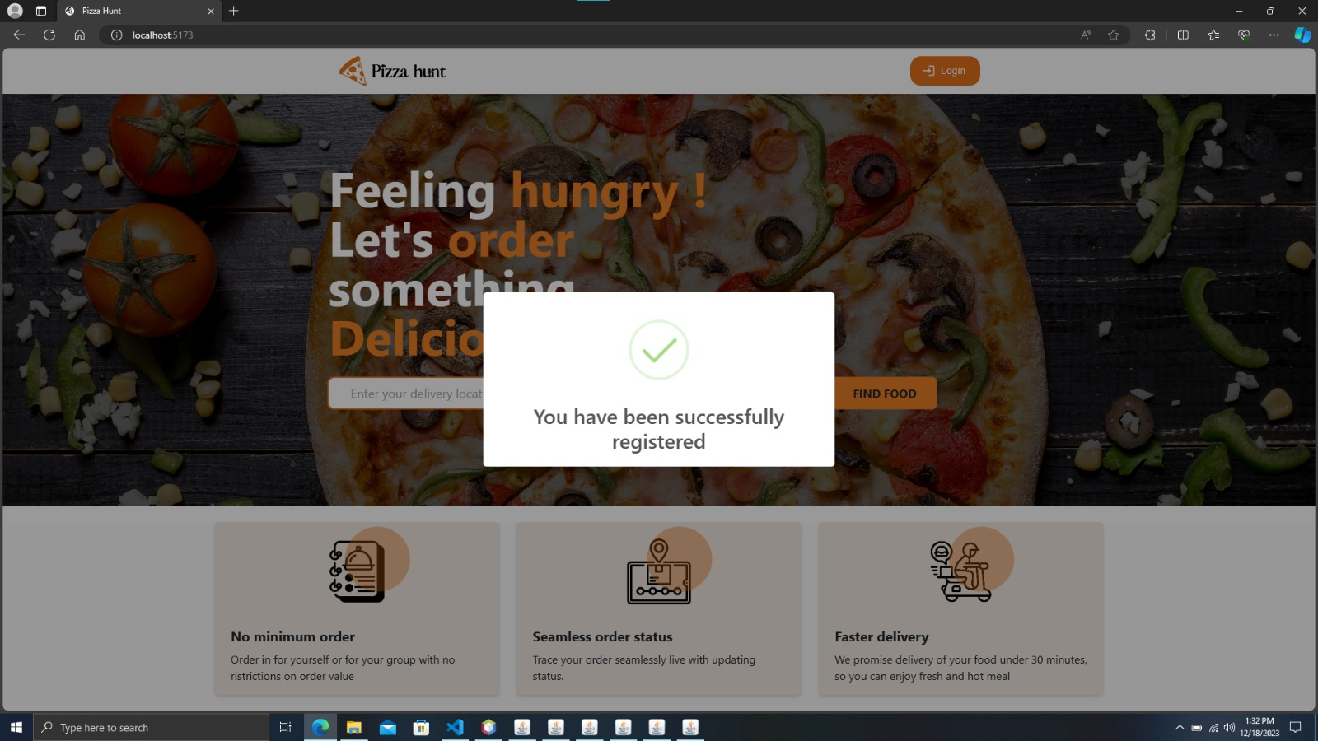

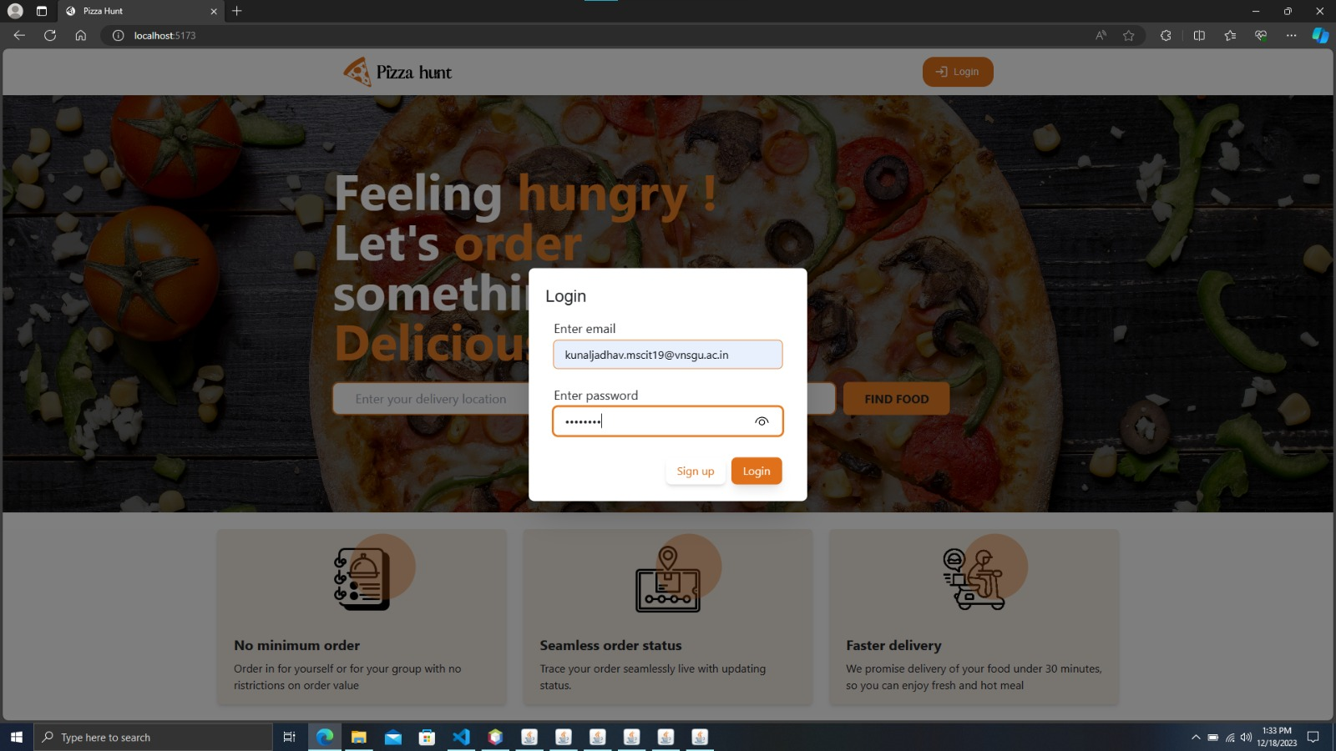

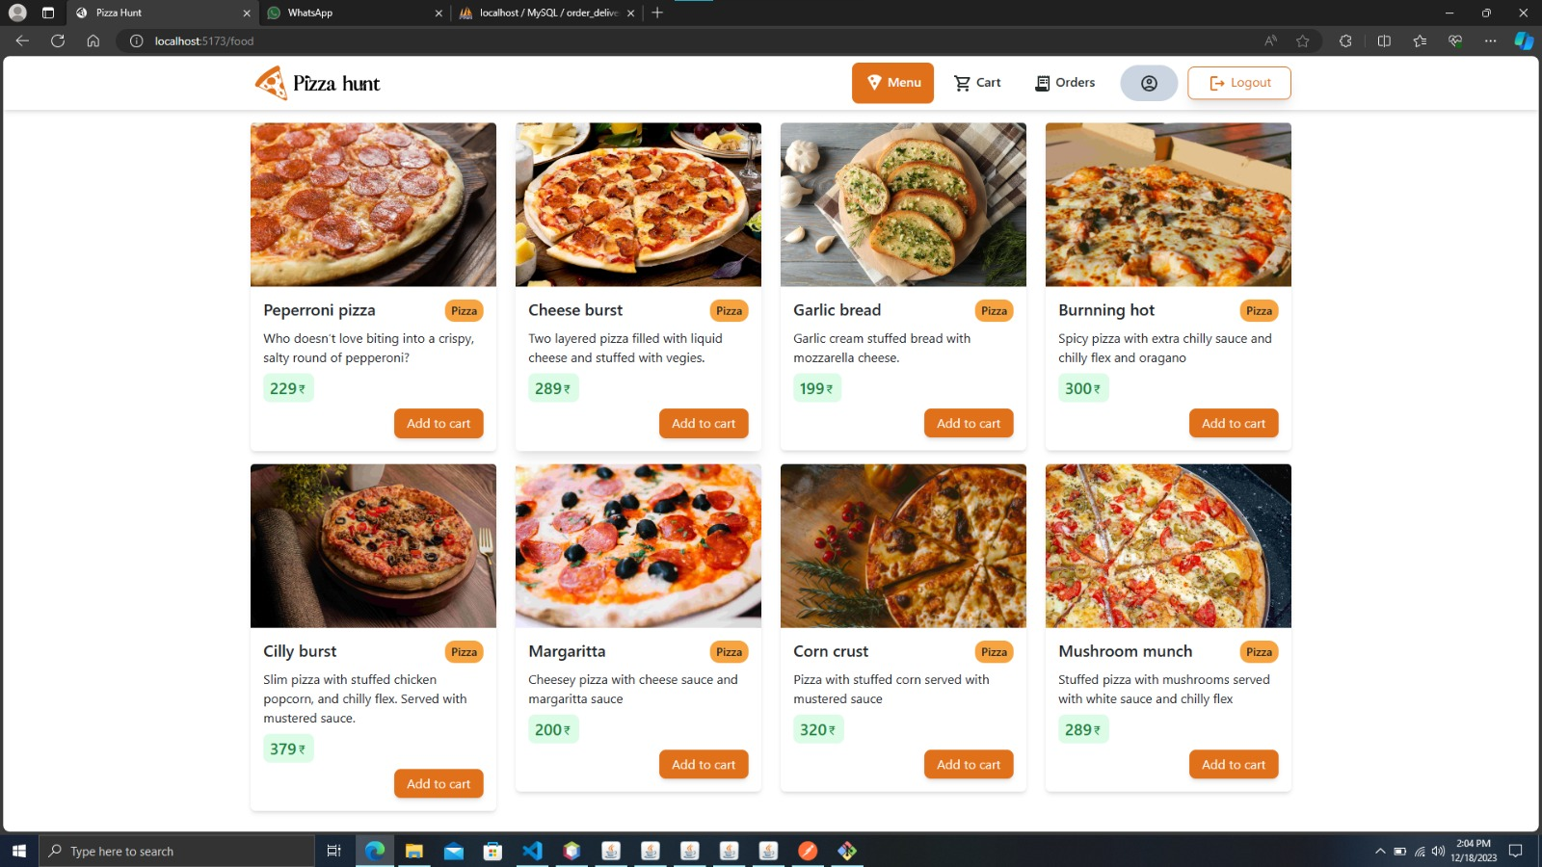

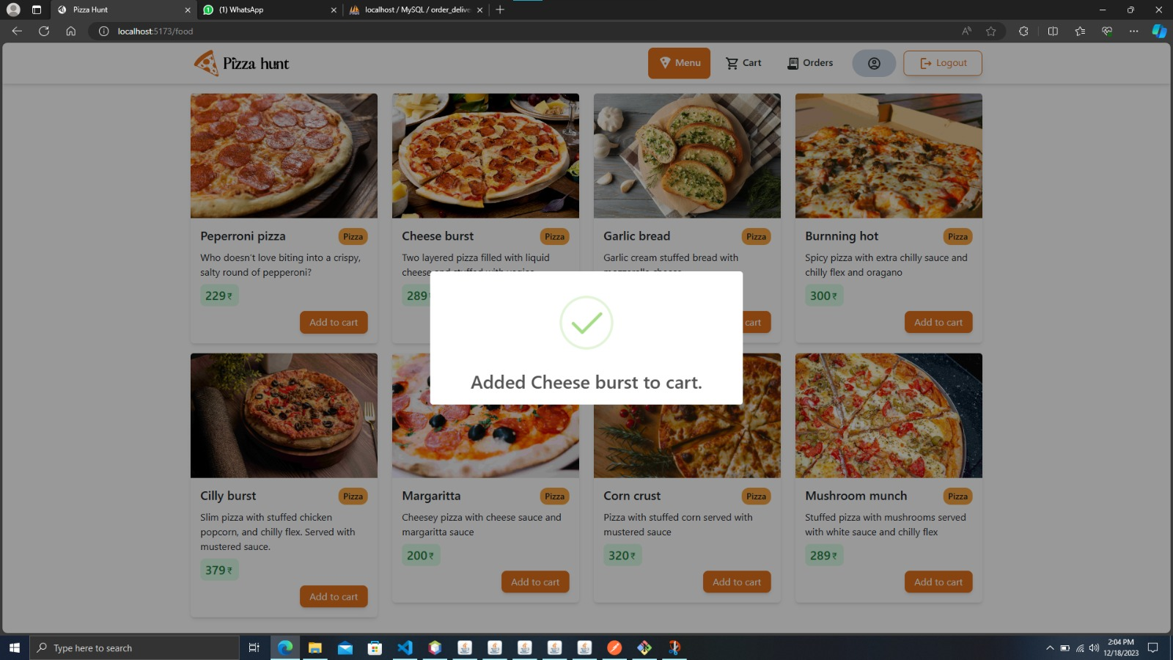

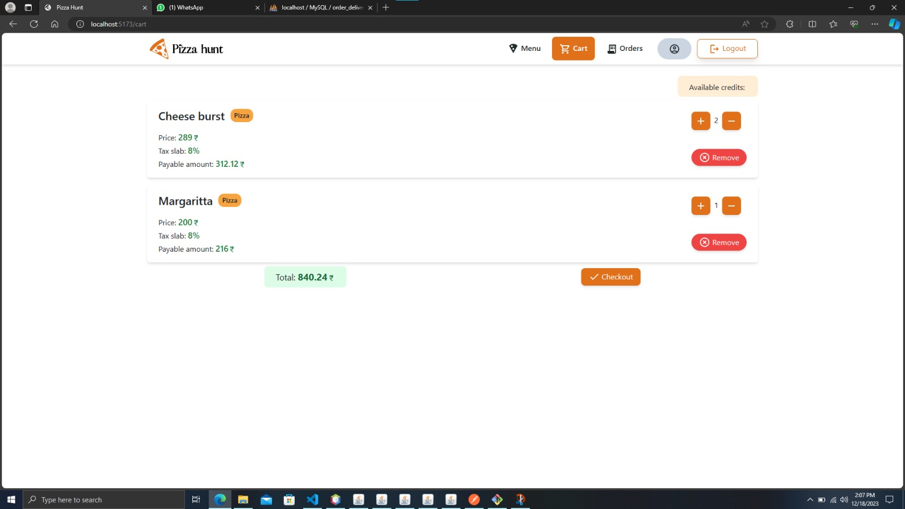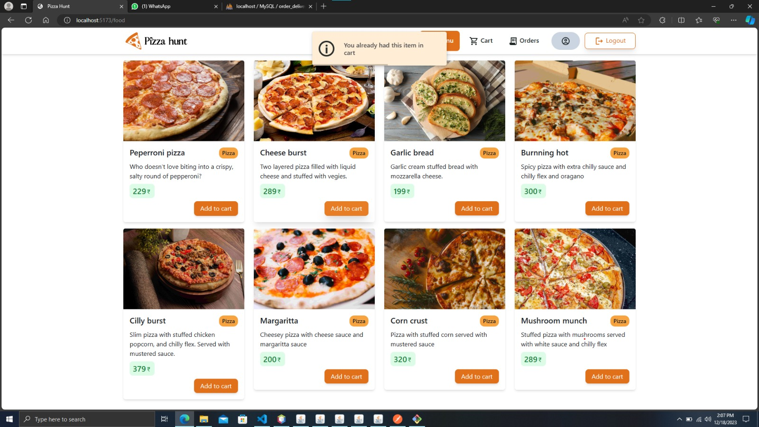

**7. Testing**

* **Login**

|  |  |  |  |
| --- | --- | --- | --- |
| **Test Field** | **Test Data** | **Valid / Invalid** | **Test Result** |
| Email | <null> | Invalid | Email is required |
|  | Bhavin | Invalid | Invalid email |
|  | Bjariwala20@gmail.com | Valid | - |
| Password | <null> | Invalid | Password is required |
|  | Password which is not in DB | Invalid | Unregistered user |
|  | True password which is in DB | Valid | - |

* **Registration**

|  |  |  |  |
| --- | --- | --- | --- |
| **Test Field** | **Test Data** | **Valid / Invalid** | **Test Result** |
| Name | <null> | Invalid | Name is required |
|  | Bh | Invalid | Name cant be too small |
|  | Bhavin Jariwala | Valid | - |
| Email | <null> | Invalid | Email is required |
|  | Bhavin | Invalid | Invalid email |
|  | Bjariwala20@gmail.com | Valid | - |
| Password | Bhavin123 |  |  |
| Password | bhavin | Invalid | Password should be alpha-numeric |
| Username | Bhavin | Invalid | Username should be alpha numeric |

* **Place Order**

|  |  |  |  |
| --- | --- | --- | --- |
| **Test Field** | **Test Data** | **Valid / Invalid** | **Test Result** |
| User Credits  < Payable amount | 1000 < 2000 | Invalid | Payment failed and order cancelled |
|  | 2000 < 1500 | Valid | Payment Successful |
| Delivery address | <null> | Invalid | Address is required |
|  | 32, Center point, adajan, surat. | Valid | Success |
| Payment method cash | <null> | Valid | Payment success |

* **Accept Delivery by OTP**

|  |  |  |  |
| --- | --- | --- | --- |
| **Test Field** | **Test Data** | **Valid / Invalid** | **Test Result** |
| Delivery person send OTP to customer via mail | If (5462== 6513) | Invalid | Order not delivered |
|  | If (1234 == 1234) | Valid | Order status delivered |

**8. Future Enhancement**

* In this online pizza ordering system, we are planning to add live order tracking for every order.
* Our goal is to make our Rest Apis efficient with response time as fast as possible to compare the response time of Kafka MQs.
* After completion of inter-service communication, we will test the response times of these services by providing bulk requests to the server.

**9. References**

* [Domino's ZERO Contact Delivery - Great Taste, Delivered Safe (dominos.co.in)](https://pizzaonline.dominos.co.in/menu)
* [Order food online from India's best food delivery service. Order from restaurants near you (swiggy.com)](https://www.swiggy.com/)
* [Best Restaurants in India - Zomato](https://www.zomato.com/india)
* [Cloud-Connectors/Kafka at master · payara/Cloud-Connectors (github.com)](https://github.com/payara/Cloud-Connectors/tree/master/Kafka)
* [Kunal8460/Rest_Order_Deliver_System (github.com)](https://github.com/Kunal8460/Rest_Order_Deliver_System)
* [Bhavin1324/kafka_order_delivery_sys (github.com)](https://github.com/Bhavin1324/kafka_order_delivery_sys)